Dr. Samindranath Mitra
Editor, Physical Review Letters

Dear Dr. Mitra,

We are writing for an update on our manuscript #LG15054 - "Charge tuning of nonresonant magnetoexciton phonon interactions in graphene". On September 3rd, we received a positive referee report, made the requested modifications and submitted our response on September 10. Since then, we haven't heard any further updates regarding this review. We also noticed various activity in early to mid September regarding correspondence with referees on the online status reports. Please provide us with further details regarding the review progress of our manuscript.

We reiterate the critical timing and importance of this work; we have been made aware of competing efforts near or just completed by several groups including Ferrari in Cambridge, perhaps the world's foremost expert in graphene Raman scattering, as well as the groups in Columbia and Grenoble.

Sincerely,
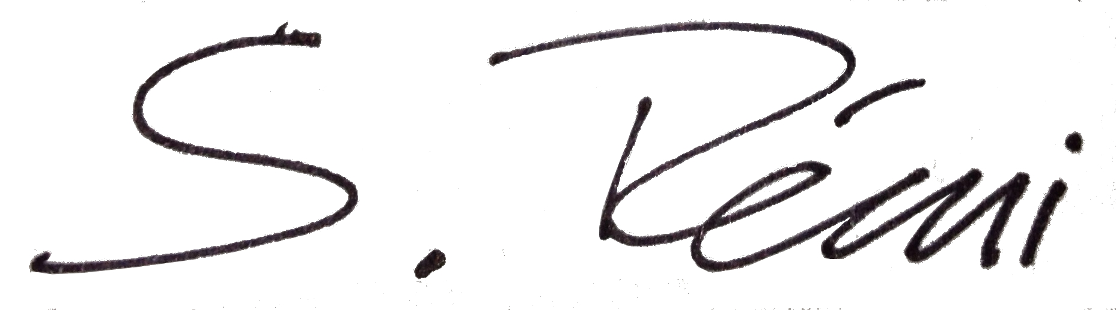
Sebastian Rémi
Research Assistant
Boston University Physics
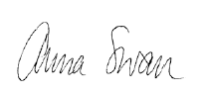

Anna Swan
Professor of Electrical and Computer Engineering
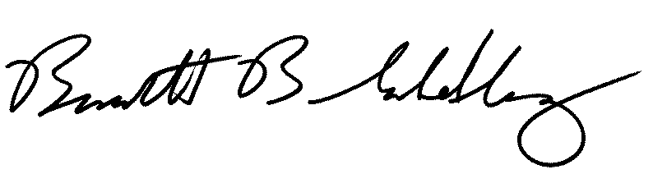
Professor of Physics

Bennett Goldberg
Professor of Physics, and Professor of Biomedical and Electrical and Computer Engineering

